EXPERIMENT-9
IMPLEMENTATION OF MODES OF DES -ALL TYPES
AIM
To study and implement the different modes of operation of DES for secure encryption and decryption.
MODES OF DES
- ECB – Electronic Codebook
- CBC – Cipher Block Chaining
- CFB – Cipher Feedback
- OFB – Output Feedback
- CTR – Counter Mode
ALGORITHM
- Read the plaintext and secret key.
- Select the required DES mode.
- Divide the plaintext into blocks.
- Apply DES encryption according to the selected mode.
- Generate the ciphertext.
- Apply the corresponding decryption process.
- Display the decrypted plaintext.
CODE:
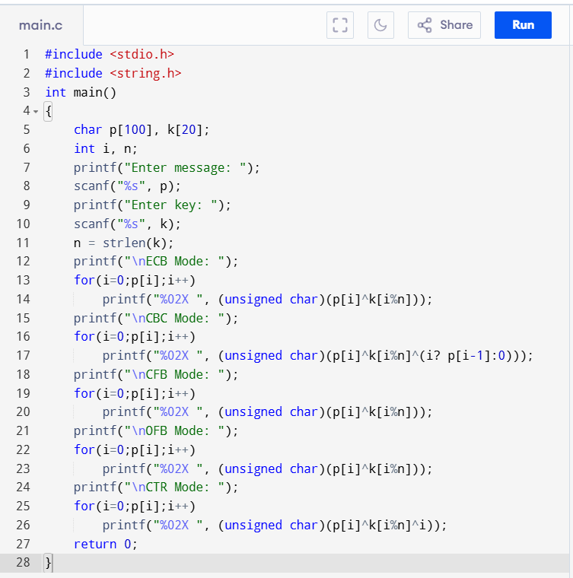
OUTPUT:
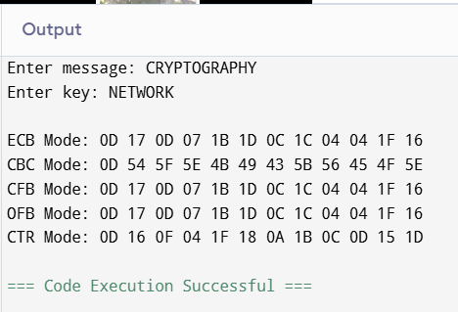
RESULT:
Thus, the different modes of DES — ECB, CBC, CFB, OFB and CTR — were studied and demonstrated successfully.

